## 1.Burn Up Chart

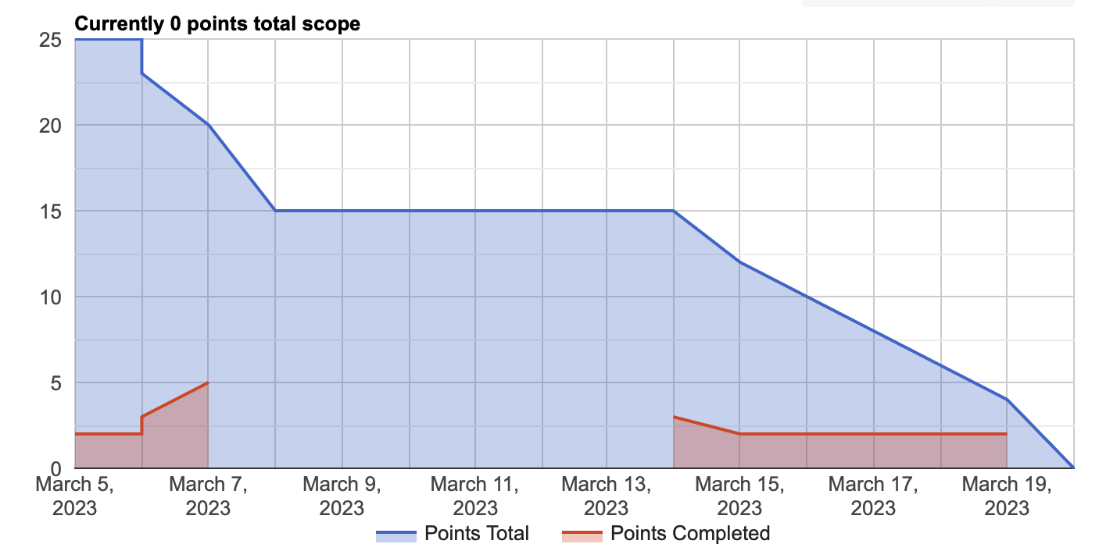

## 2.Trello Invite

Please join trello with [this](https://trello.com/invite/b/pXTlCnae/ATTIb5db12b891b71f0fb1c9d0e4c00eb26d7EF2F499/sobek-transit) link.

## 

## 

## 

## 

## 

## 3.UI Screenshots

